Tanner Foot & Ankle Clinics
PATIENT HISTORY FORM
Patient’s Name: __________________________Today’s Date: __________ Date of Birth: _____________
How did you hear about us (circle): Yellow Pages, Radio, Doctor, Patient, Internet, Other: _______________
History of Present Illness
Reason for your visit today: _______________________________________________________________
What do you think the problem is? _________________________________________________________
Are there specific treatments you would like to try? _____________________________________________
Is this a result of an injury? ______ Has this been reported? ____ (ER, Job, Police, Legal, Workers Comp)
Onset of problem: ______________________________________________________________________
Previous Problems: ____________________________________________________________________
Treatments tried already (circle): Rest, Ice, Elevation, Tylenol, Ibuprofen, Bandage, inserts, Orthotics, Physical therapy, Seen other providers for this problem/Whom___________________________________________
____________________________________________________________________________________
Describe the pain____________________________ Describe the area____________________________
Does the pain (circle): Travel Stay local Other:______________________________________
Pain on Scale of 1-10:____/10 Sitting Standing___/10 Walking___/10
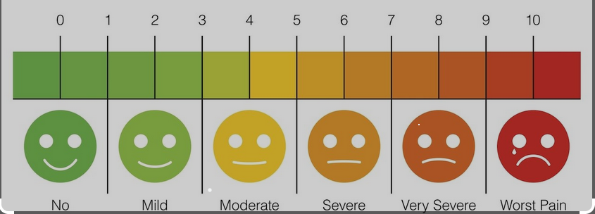When is it most painful__________Why is it more painful?___________When is it best?:______________
Anything else you have also noticed? _______________________________________________________ Please Circle place of problem (be specific please)____________________________________________
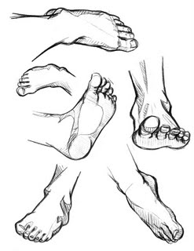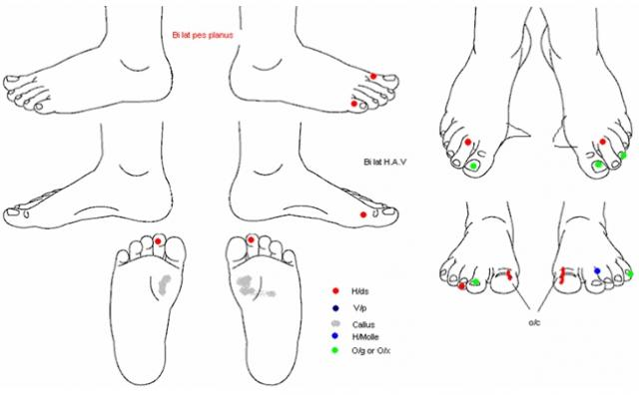
Past Medical History
Primary Care Physician’s name & Location: __________________________Date of last exam:_________ Have you ever been hospitalized? □Yes □No If yes, what for? ___________________________________
Do you currently feel sick? Yes No. If yes describe symptoms:_________________________________
Conditions are you currently being treated or have been treated for in the past (please check)
□Heart disease / Murmur / Angina □ Breathing Disorder □Eye disorder / Glaucoma □Diabetes-HgA1c:___
□High cholesterol □Asthma □Seizures □Kidney / Bladder problems □High blood pressure
□Lung problems □ cough □Stroke □Liver problems / Hepatitis □Low blood pressure □Sinus problems □Headaches / Migraines □Arthritis □Heartburn (reflux) □Seasonal allergies □Neurological problems □Cancer □Anemia or blood problems □ Poor Blood Flow □Tonsillitis □Depression / Anxiety □Ulcers/colitis □Swollen ankles □Ear problems □Psychiatric care □Thyroid problems
Please describe any current or past medical treatment not listed above
____________________________________________________________________________________
Please list your past surgeries and year performed:__________________________________________
____________________________________________________________________________________
Did you have any problems with (circle): Anesthesia, Bleeding, Healing, Scarring, Medications, Other:______
Over

What other specialists have you seen in the last 5 years?:
Whom Reason Treatments performed
_____________________ __________________________ _____________________________
_____________________ __________________________ _____________________________
_____________________ __________________________ _____________________________
Allergies
Are you allergic to any of the following (circle): Penicillin Sulfa drugs Betadine Iodine dye Certain Metals Latex Adhesives Others-Please list:_______________________________________________________ ____________________________________________________________________________________
Medications -Include Prescriptions, Over the counter medications and, supplements, etc. If you have a copy of your medications already please circle (photocopy) and attach so we can make a copy instead.
Name of: Dose: When taken:
Do you currently smoke or chew tobacco? □Yes □No If no, have you in the past? □Yes □No
How many packs per day? _______________________ How many years?:________________
Do you drink alcohol, beer, or wine? □Yes □No How many drinks per week? ______________________
Do you currently drink coffee and/or tea? □Yes □No If yes, how many cups per day?__________________ Do you exercise daily/weekly? □Yes □No If yes what?_________________________________________
Employment Conditions: [ ] Sits at Job [ ] Stands at Job [ ] Stands & Walks at Job [ ] Retired
Job Title:__________________ Sexually transmitted disease? □Yes □No Diagnosis: ____________
Family History
Living Age (or age at death) List serious illnesses
Mother □Yes □No ____________________________________________________________________
Father □Yes □No ____________________________________________________________________
Sisters □Yes □No ____________________________________________________________________
□Yes □No __________________________________________________________________________
Brothers □Yes □No ___________________________________________________________________
□Yes □No__________________________________________________________________________
Is there any chance you may be pregnant (circle): Yes No_____If yes, tell Dr Oaks when present as well.
By signing below, I hereby certify that the information I have furnished on this form is complete, true and accurate.
Patient/Legal Guardian Signature ______________________________ Date _____________

